Model order reduction in ROTFE 2.0

The most general model represented by ROTFE can be described by the following equation:

(1)

where 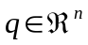

All model reduction techniques within ROTFE look for a transformation:

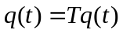 (2)
Where 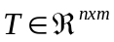 and m < n

Substituting equation 2 in equation 1 and multiplying by 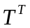 to the left gives us the reduced-size equation of motion

(3)
Where, for example:
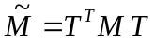, 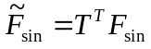

The methods used in ROTFE 2.0 differ by the selection of T.

- Since version 2.1 rotfe.m calls the appropriate model order reduction technique (as explained below). This is accomplished by using the field Rot.Reduct.Type before caling rotfe.m.
- The options for Type are 'modal', 'mixed' and 'static'
- See: tst_reduce1.m
- reduce

Purpose Create a reduced order model (Reduct.Type='modal')

Synopsis Rot=reduce(RotFull)

Description A transformation of the state vector is computed. The transformation is applied to the mode and a new reduced-order mode is created.
The transformation is formed by selecting its columns out of the eigenvectors which is obtained by solving the undamped eigenvalue problem.
Examples In this example, a simple rotor model is created and the unbalance response of the full and reduce model are computed.

» Rot=rotfe('academyr1'); % create model for academyr1 model file
» Rot.Reduct.Nmodes=8; % specify no. of modes
» tic, [U w]=rotunbal(Rot,9000,200); toc % compute unbalance 0-9000 RPM & measure time
elapsed_time =
1.7600

» Rot1=reduce(Rot); % perform reduction
» tic, [U1 w]=rotunbal(Rot1,9000,200); toc % compute unbalance for reduced model
elapsed_time =
0.3300

» semilogy(w,abs(U(:,2)),w,abs(U1(:,2)),'x') % compare both computations
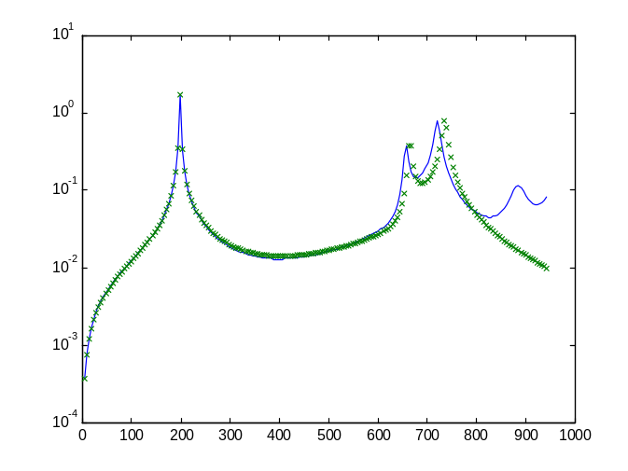

See Also reduces, reduceg, simrotor, rotunbal Reduct.Nmodes in the mode file

Theory reduce.m

In this method, a subset of the non-rotating eigenvectors (solution of 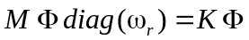). is being used.
Using Matlab™ notation, we write: 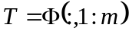.
The selected modes are determined by :
- Specifying a number for Reduct.Nmodes in the mode file, e.g. Reduct.Nmodes=6;
- Explicitly modifying the appropriate field in the rotor data structure before calling either one of the reduction methods, for example:
Rot=rotfe('simple1r');
Rot.Reduct.Nmodes=6;

The selected modes are always taken from the lower part of the spectrum (lower natural frequencies)
reduces

Purpose Create a reduced order model (mixed reduction) (Reduct.Type='mixed')

Synopsis Rot=reduces(RotFull)

Description A transformation of the state vector is computed. The transformation is applied to the model and a new reduced-order mode is created.
The transformation is formed by selecting its columns out of the eigenvectors which is obtained by solving the undamped eigenvalue problem and a so called Guyan (or static reduction). The response co-ordinates specified in the model file (RnodeDir) determine the so-calles master DOFs for the Guyan reduction.
Examples In this example, a simple rotor model is created and the unbalance response of the full and reduce model are computed.

» Rot=rotfe('academyr1');
» MASTER_DOF=Rot.RESP_DOF' % these equations will be master

MASTER_DOF =
1 2 9 19 20 26

» Rot.Reduct.Nmodes=8;
» Rot2=reduces(Rot);
» tic, [U2 w]=rotunbal(Rot2,9000,200); toc

elapsed_time =

0.6600

» semilogy(w,abs(U(:,2)),w,abs(U2(:,2)),'o')

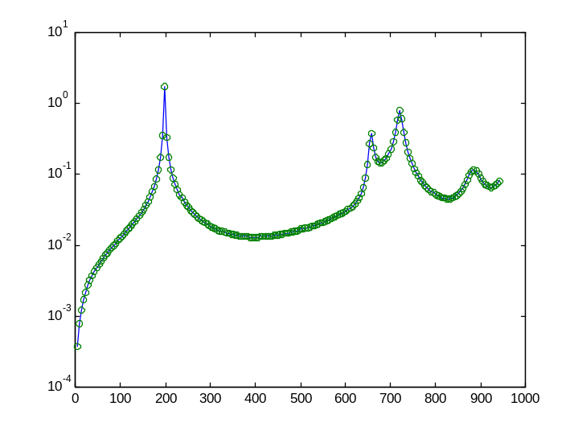

Theory reduces.m

In this method a subset of the non-rotating eigenvectors (solution of ).
Using Matlab™ notation, we write: . Additional columns of the transformation matrix are added. In conclusion the transformation matrix takes the form:

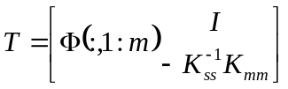
Where the indices s and m stand for slave and master dofs.

The selected modes are determined by :
- Specifying a number for Reduct.Nmodes in the mode file, e.g. Reduct.Nmodes=6;
- Explicitly modifying the appropriate field in the rotor data structure before calling either one of the reduction methods, for example:
Rot=rotfe('simple1r');
Rot.Reduct.Nmodes=6;
c) The master degrees of freedom can be selected by specifying RNodeDIR in the model file, or
- directly modifying the RESP_DOF field (After running rotfe).
e.g. Rot.RESP_DOF=[1 2 14 ];

reduceg

Purpose Create a reduced order model (Reduct.Type='static')

Similarly to reduce and reduces this function performs model reduction where the Guyan(static) reduction is applied.

Example:

» Rot3=reduceg(Rot);
» tic, [U3 w]=rotunbal(Rot3,9000,200); toc

elapsed_time =

0.3300

» semilogy(w,abs(U(:,2)),w,abs(U3(:,2)),'o')

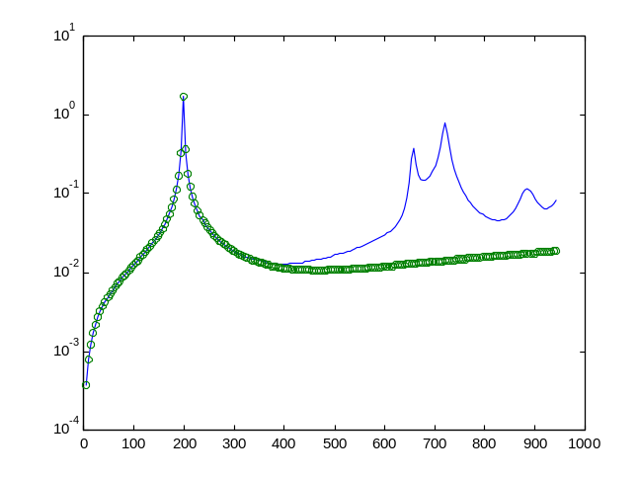

The static reduction, by itself provides a reasonable estimate for the low frequency range.

* * Example: see tstreduct1.m for a comprehensive example

Using Simulink™ with ROTFE 2.0

In order to simulate a rotor system according to equation (1). A Simulink™ block was created.
This block implements an sfunction (see Simulink documentation) by means of a Matlab function: rotsfuncw.m.
The programming is done by means of a graphical interface, which is provided by the Simulink in environment. The sfunction block was masked so that the only input, which is necessary, is the name of the mode file from which all the necessary model parameters are generated.

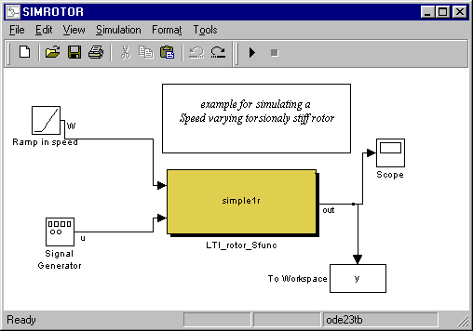

As evident from the above figure, the model needs to be supplied with two inputs: (1) a time function which represents the speed of rotation (in [Rad/s]). (2) an external force vector (u(t) in equation 1.
The size of the external input vector and the locations at which force is to be applied is determined by the variable FnodeDir, which is defined in the model file.

In the EXAMPLE shown above, the model file simple1r.m is being used, in this model the definition
FNodeDir=[ 3.1 ]; selects a force acting at node no. 3 in the x-direction (use drawrot simple1r to visualize the model),

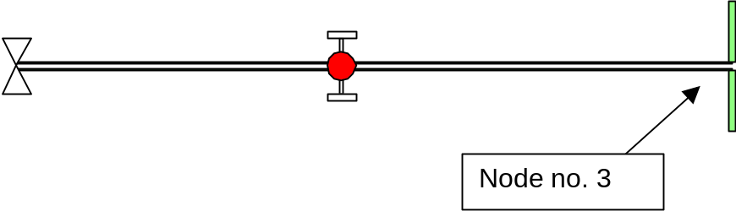

Important Notes:

Most structural models give rise to stiff equations, which are difficult to integrate. Within Matlab5.2 new methods have been introduced in particular the ode23tb (stiff/TR-BDF2) should be used for such models. In addition to that, the desired tolerance (both relative and absolute) should not be smaller than 0.01. Otherwise, the simulation may last a long time.

The mode is automatically reduced using a mixed reduction technique according to the suitable parameters (see the description of reduces.m).

Run the simulation by activating the ►button. Upon comletion the scope should display the output plot (double-click on the scope to open it and use the binoculars to resize the plot).

Since in this simulation the output is stored in a workspace variable – y. we can simply plot(y) or compute the spectrogram, by typing

specgram(y(:,1))

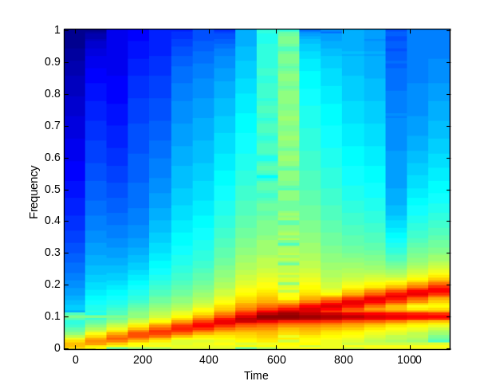

One can observe the effect of unbalance due to the lineraly varying speed of rotation. The coincidence of the speed of rotation with one of the natural frequencies gives rise to highe response levels.

Creating a new simulink model : example of writing a simulink model

We wish to simulate the behavior of the model we have shown above (simple1r) and add a stiff contact spring acting in the y-direction at node no. 3. In addition we assume that there is a sinosiodal force acting at node 3 in thex direction. The model is shown schematically below:

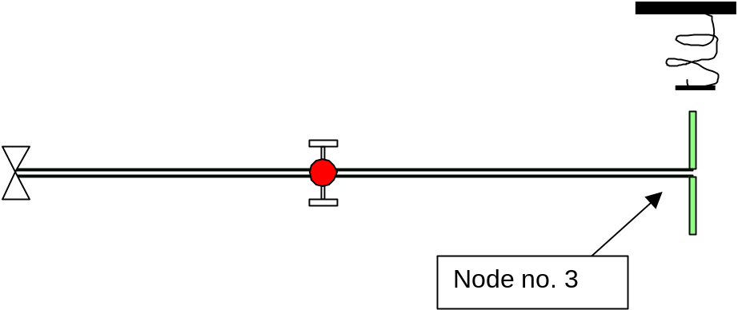
➔ Due to a bug in the Simulink MUX block. We have to create a new Simulink block when more than one force is being used. This block has a single (vector) input and is shown below

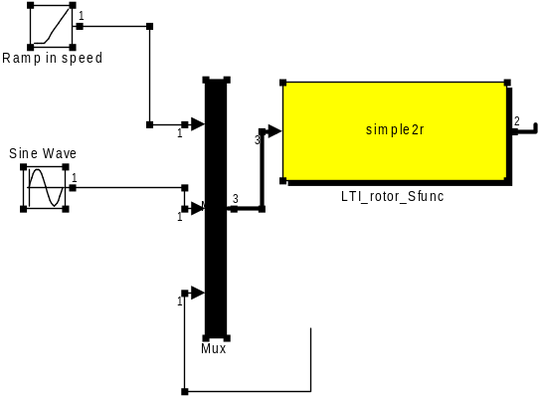

The block much be fed the speed of rotation (in [Rad/s]) as the 1st input and all other inputs (in this case 2) are connected to the 2nd 3rd etc. (type simrotordemo to obtain this block + the MUX)

The stages required to generate a simulation are described below:
Step 1, create a model file
copy simple1r to a file named simple2r.m.
change the line FNodeDir=[ 3.1 3.3 ]; % 3.1 for the x-direction 3.3 for the y-direction)

Step 1, create a Simulink program
Open a new Simulink (model) window (select file/new from any Simulink window). Type rotlib within Matlab to open the library. Drag the LTI_rotor_Sfunc_W into the empty window. Type simrotor and drag the Ramp in speed icon into the empty window. Double click on the rotor (LTI_rotor_Sfunc_W) block and make sure the model name is simple2r. Connect the ramp in speed block to the first line of the MUX (which should be dragged from the library too). The MUX allows us to convert several scalar inputs into one vector line.Type Simulink inside Matlab to open the main Simulink library and from Nonlinear drag f(u) into the simulation window.
Connect the input of f(u) into the output of the rotor model block and the output of f(u)into the second input of MUX. Double click on f(u)and type inside -1e2*( abs(u(1))>0.1)*sgn(u(1)).
This function creates a spring (with rate 100) which comes into contact only when the response (u(1)) is larger than the gap (0.1).

Create a simulation, which looks like this

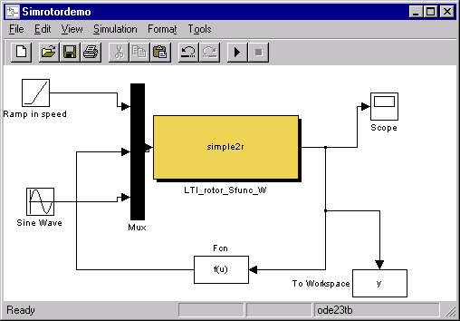

➔ The To Workspace Block is optional and can be added later.
➔ ➔ the above example was saved in a file: simrotordemo

➔ ➔ ➔ Reminder, choose a stiff integration routine (ode23tb in Simulation/Parameters), choose 0.1 as both tolerances.
➔ When using the To Workspace block, the output can be saved in the matlab workspace for later calculations. It is possible to compute the speed-frequency change by typing specgram(y(:,2)).

